**Software Design And Testing**

**Term work**

**Definition:**

Ticket Ease - a ultimate solution for hassle-free ticket booking from anywhere, anytime.

**Scope:**

* Book Tickets Of Any Type that is Flight, Bus, Train From App.
* User Can Use This System 24*7.

**Requirements:**

* Client Wants One Login Page.
* User Can Search Tickets, If Available Tickets are There User Can Book Tickets By Giving Payment details.
* After Payment Confirmation With Bank Ticket Is Mailed To User.

**Specification:**

* Easy To Use for Users.
* User Can Do Booking So That Reservation Ticket he/she Get.

**Class Diagram:**

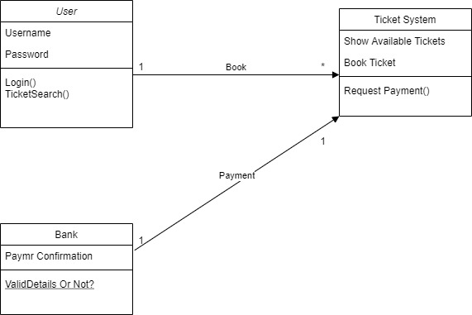

**Use case Diagram:**

1. **For Login.**

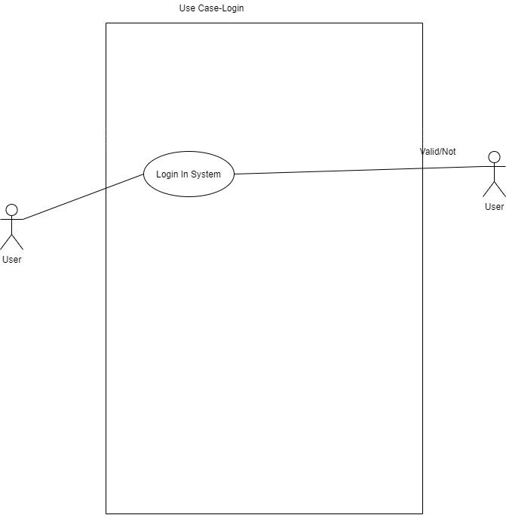

1. **For Booking**

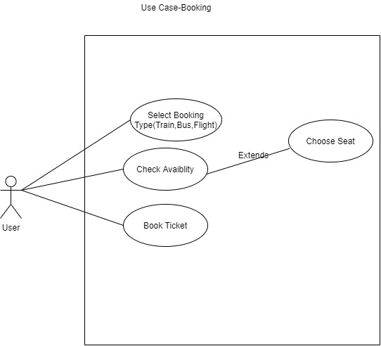

**Sequence Diagram:**

1. **For Login**

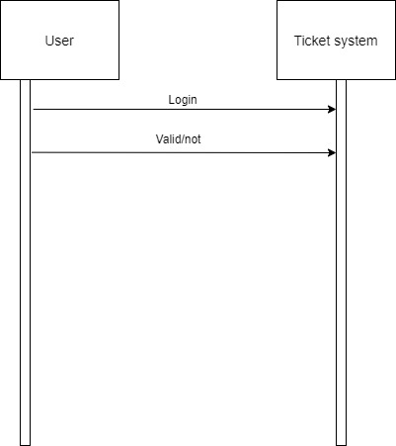

1. **For Booking**

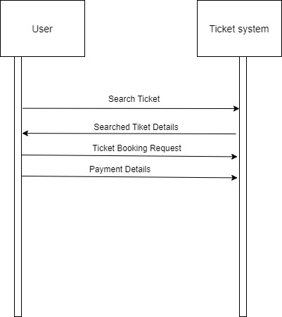

**Collaboration Diagram:**

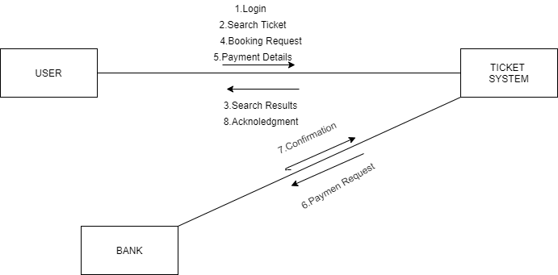

**Activity Diagram:**

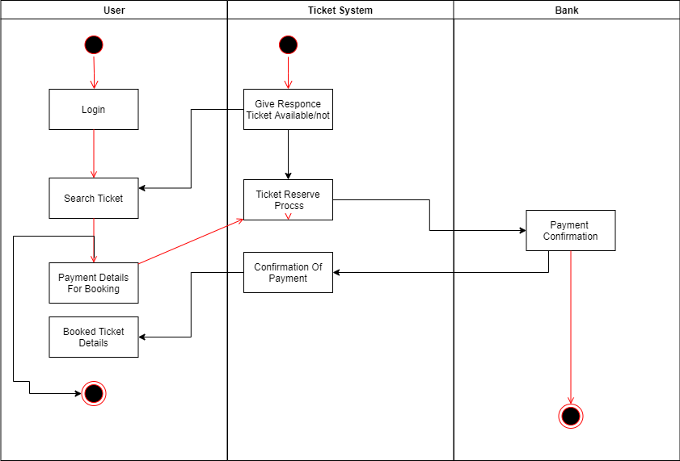

**State Chart Diagram:**

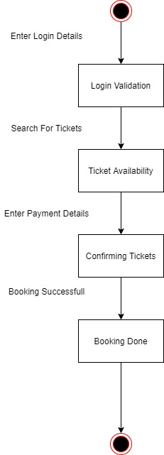

**Component Diagram:**

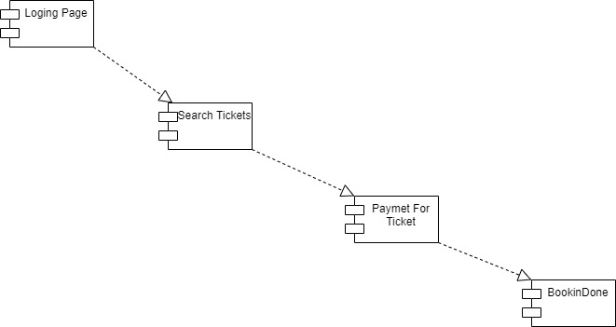

**Deployment Diagram:**

